EXERCISE 16 - JEAN RAVEN MAGALING

- List IDs, birth dates, and emails of employees born in April.
SELECT e_id, birth_date, p_email
FROM employee_per
WHERE MONTH(birth_date) = 4;
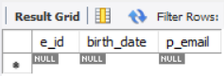
- Display IDs, birth dates, and spouse names of employees born in 1969, and sort the entries on the basis of spouse names.
SELECT e_id, birth_date, s_name
FROM employee_per
WHERE YEAR(birth_date) = 1969
ORDER BY s_name;
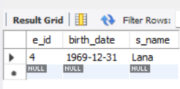
- List the employee IDs for employees born under the current month.
SELECT e_id, birth_date
FROM employee_per
WHERE MONTH(birth_date) = MONTH(CURRENT_DATE);
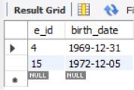
- How many unique birth years do we have?
SELECT COUNT(DISTINCT YEAR(birth_date)) AS unique_birth_years
FROM employee_per;
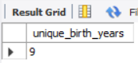

- Display a list of unique birth years AND the number of employees born under each.
SELECT YEAR(birth_date) AS birth_year,
COUNT(*) AS employees_born
FROM employee_per
GROUP BY YEAR(birth_date)
ORDER BY birth_year;
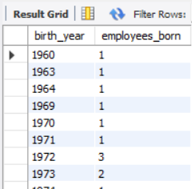
- How many employees were born under each month? Display month names (NOT numbers) and sort by largest count first
